**Minor Project AWS:**

Question) Create an S3 bucket and show the process of Static website Creation.

Answer)

***Creating an S3 Bucket:***

**Step 1:** Login into the AWS Management Console.

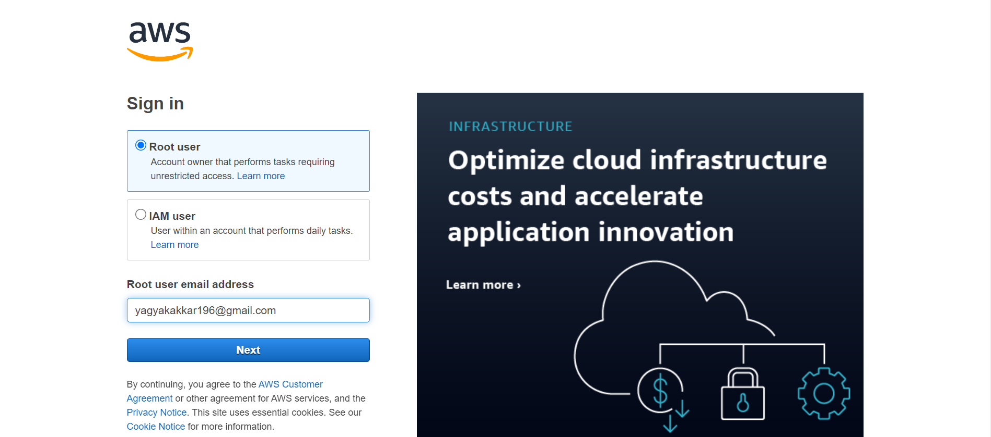

**Step 2:** Go to S3(Simple Storage Service) and click on Create Bucket.

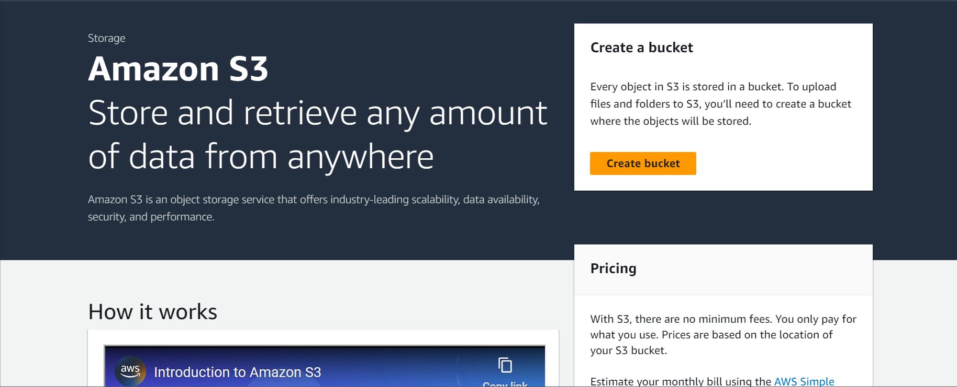

**Step 3:** Enter your details as done in the below screenshot:

* Bucket name – awsprojectyagya.
* AWS Region – Asia Pacific (Mumbai) ap – south – 1.
* Disable ACLs (Access Control List).

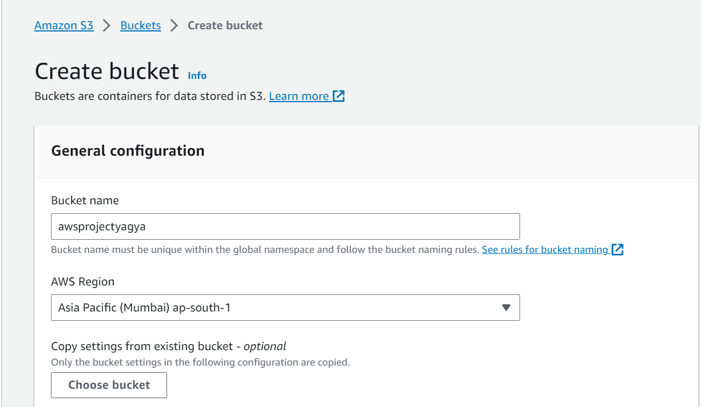

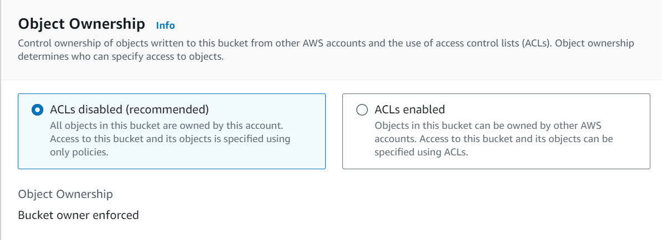

**Step 4:** Uncheck Block all public access.

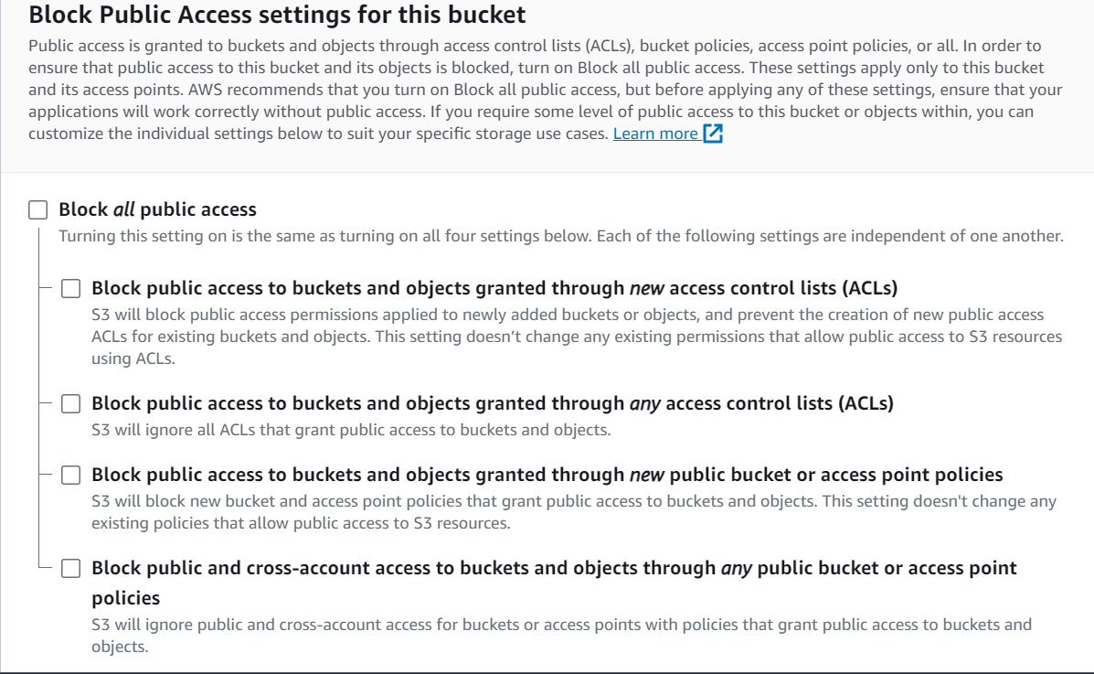

**Step 5:** Provide acknowledgment by checking the box.

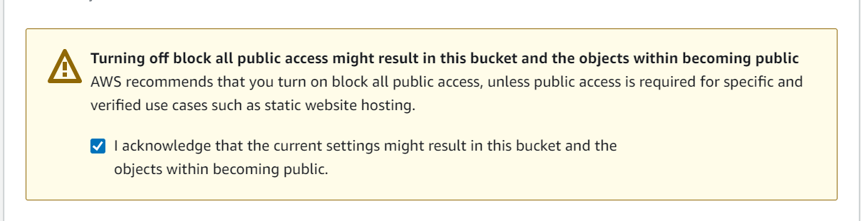

**Step 6:** Enable bucket versioning so that we can keep multiple variants of an object in the same bucket.

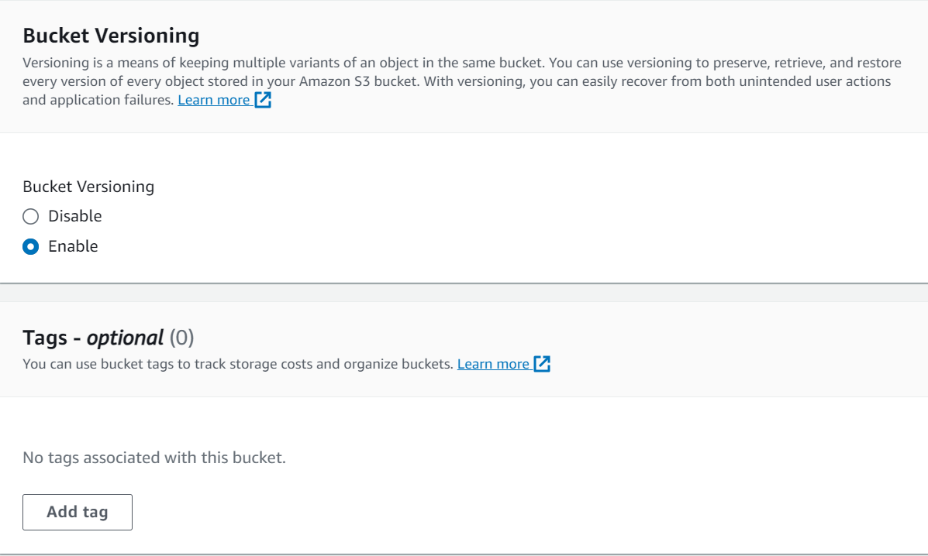

**Step 7:** Choose the encryption type as Server-side encryption Amason S3 managed keys (SSE-S3) and enable Bucket Key.

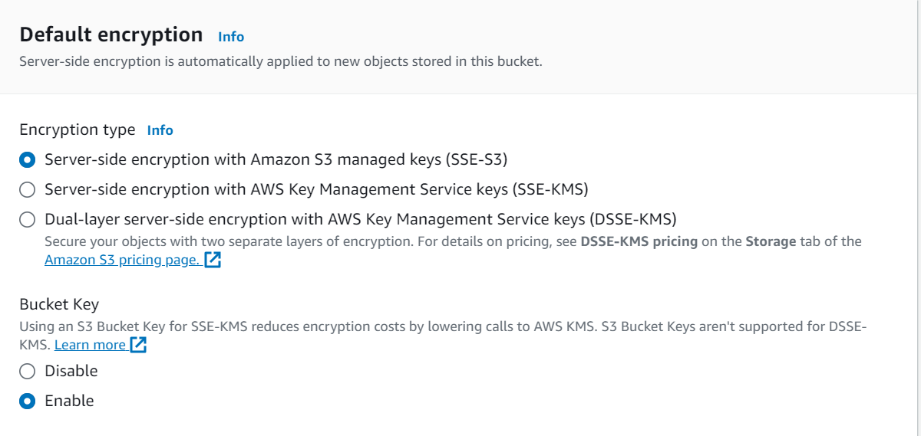

**Step 8:** Click on Create Bucket to see that the bucket with the name awsprojectyagya is created.

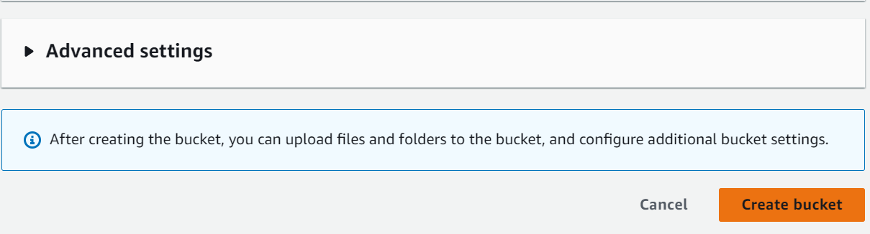

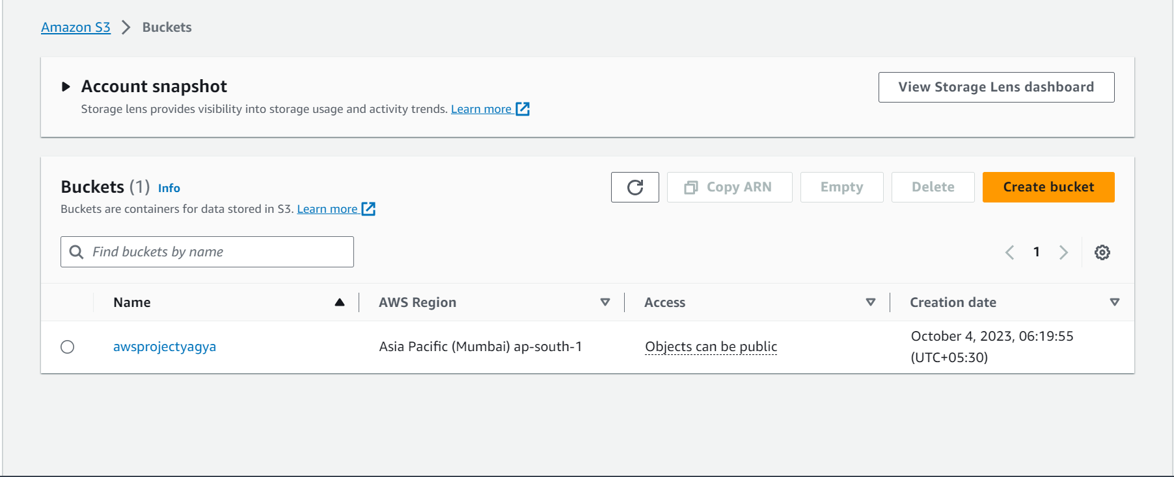

***Creation of Static Website:***

**Step 9:** Now, in the bucket – awsprojectyagya, we can store objects of our choice.

* Click on Create folder and add a folder named – minor project.

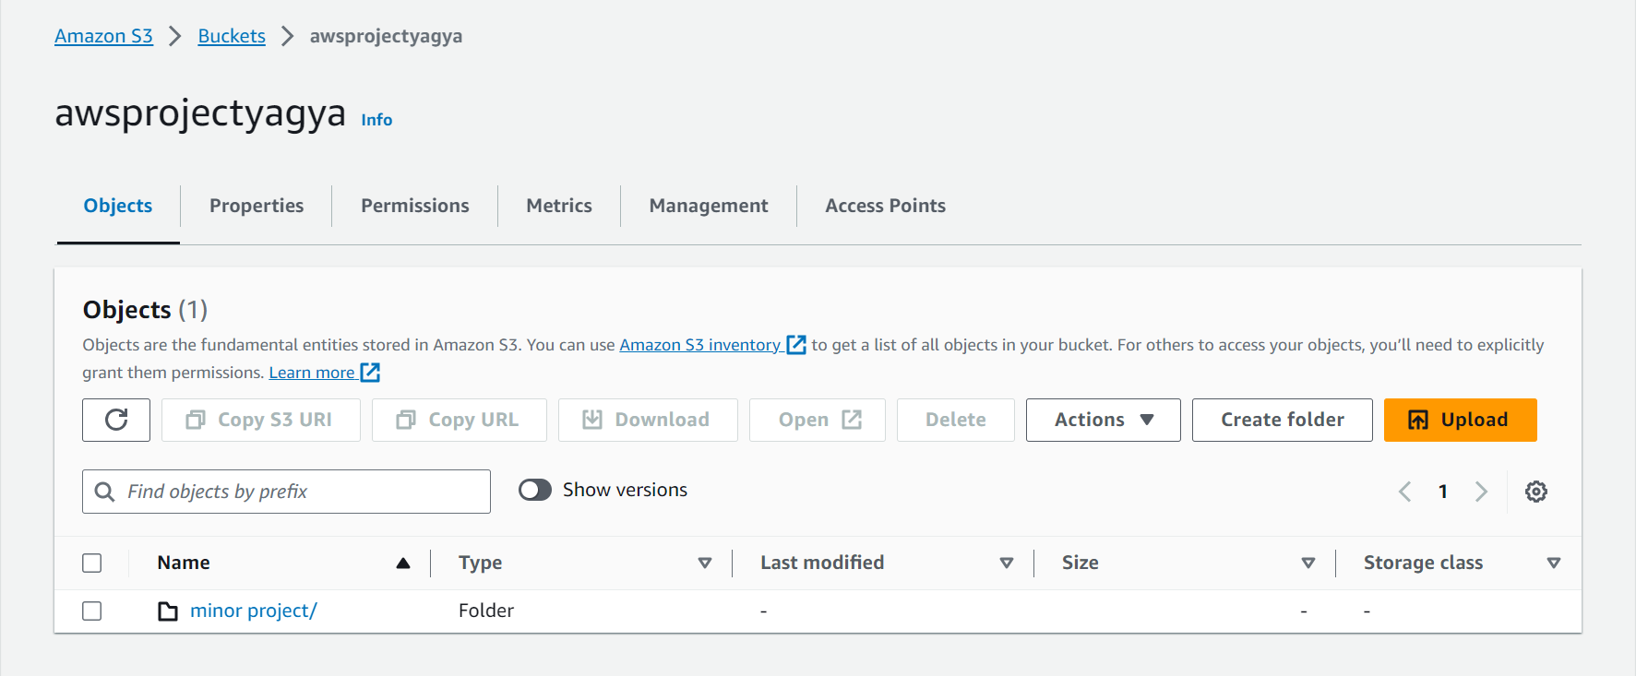

**Step 10:** In the folder – minor project, add your .html file and click on upload.

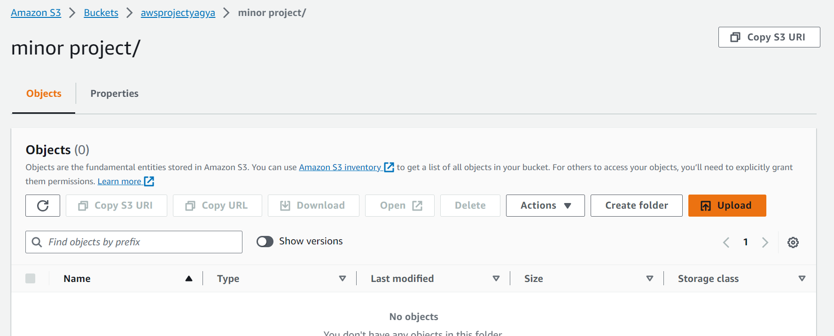

**Step 11:** Add Object Surveyform.html from your desktop and click on upload.

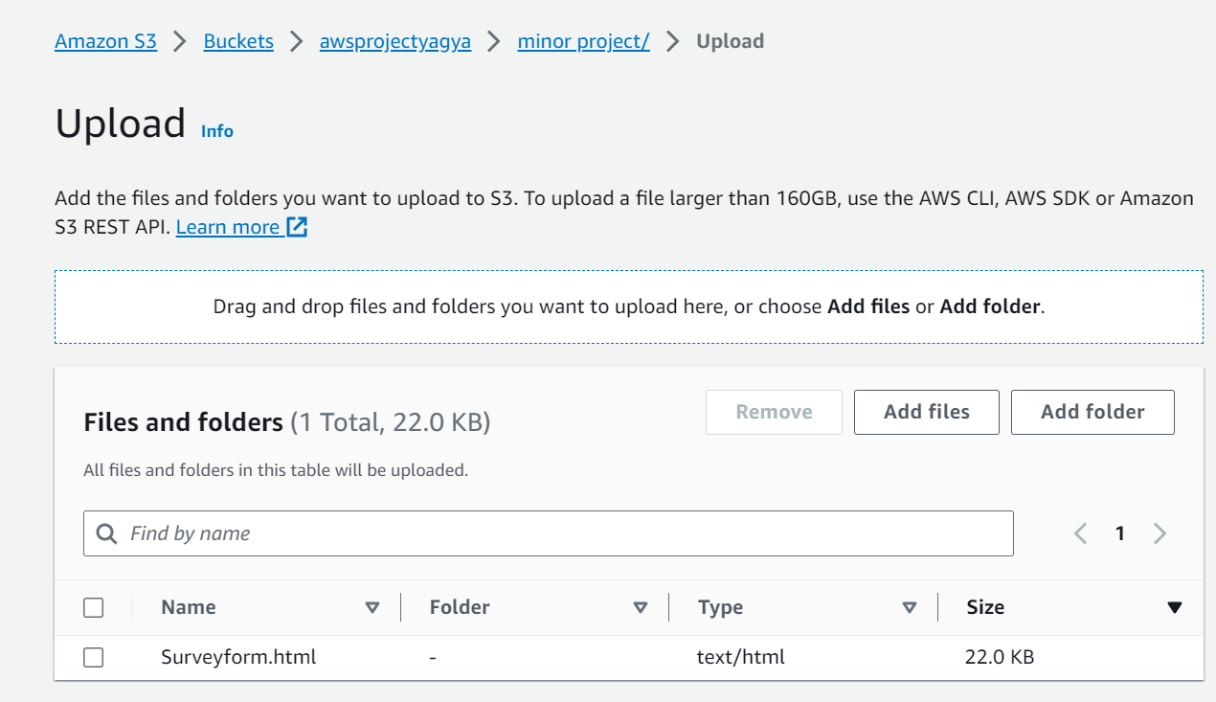

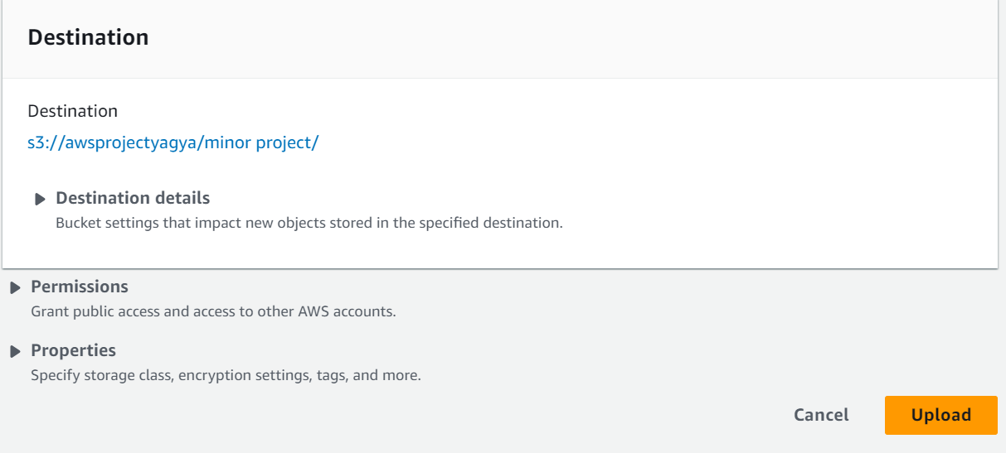

**Step 12:** Object Surveyform.html will be uploaded into the bucket minor project.

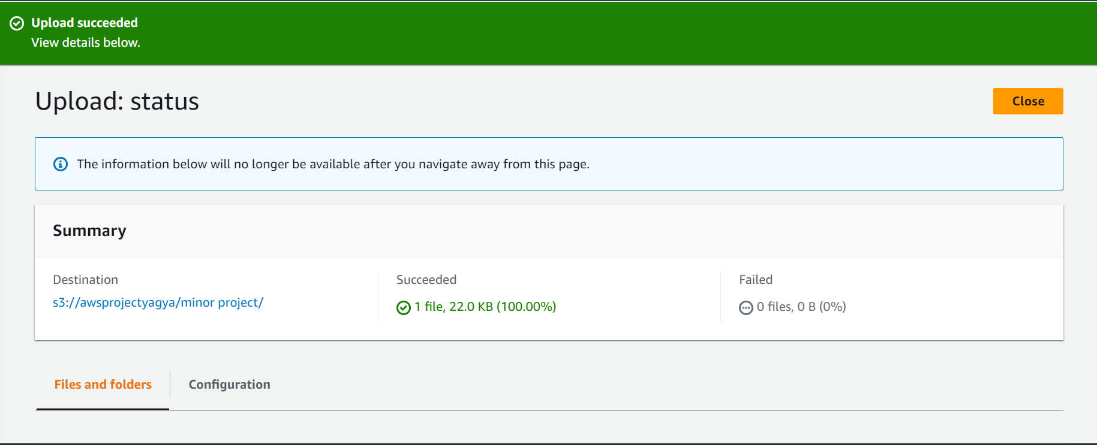

**Step 13:** To make this object publicly available we will go to Permissions.

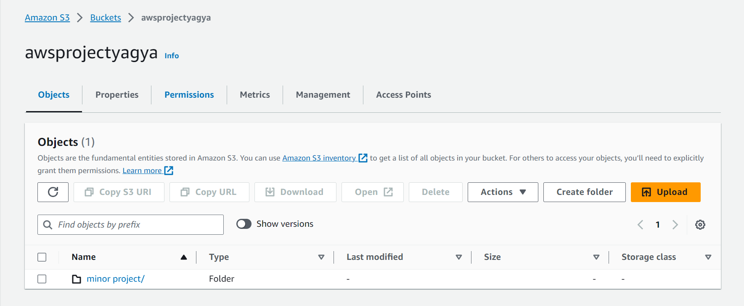

**Step 14:** Click on Edit Bucket Policy.

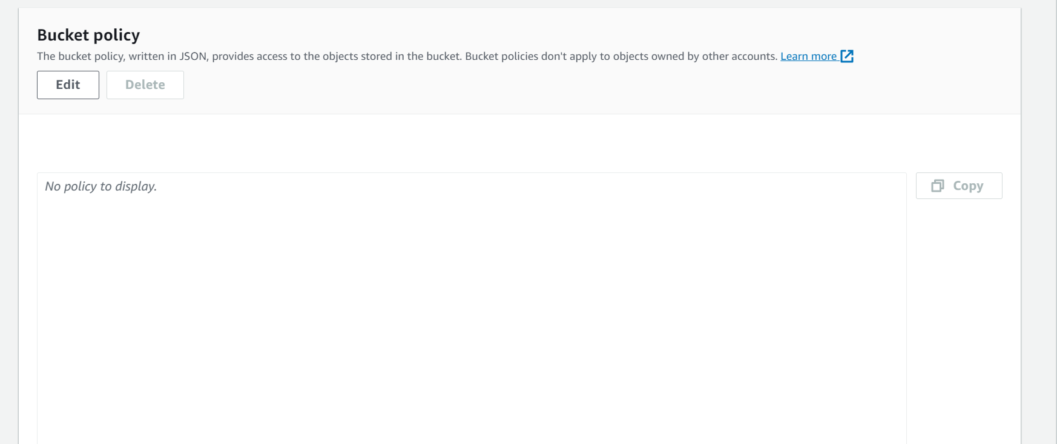

**Step 15:** Add the following Bucket policy to make your object Public:

{

"Version": "2012-10-17",

"Statement": [

{

"Sid": "awsprojectyagya",

"Effect": "Allow",

"Principal": "*",

"Action": "s3:GetObject",

"Resource": [

"arn:aws:s3::: awsprojectyagya/*",

"arn:aws:s3::: awsprojectyagya"

]

}

]

}

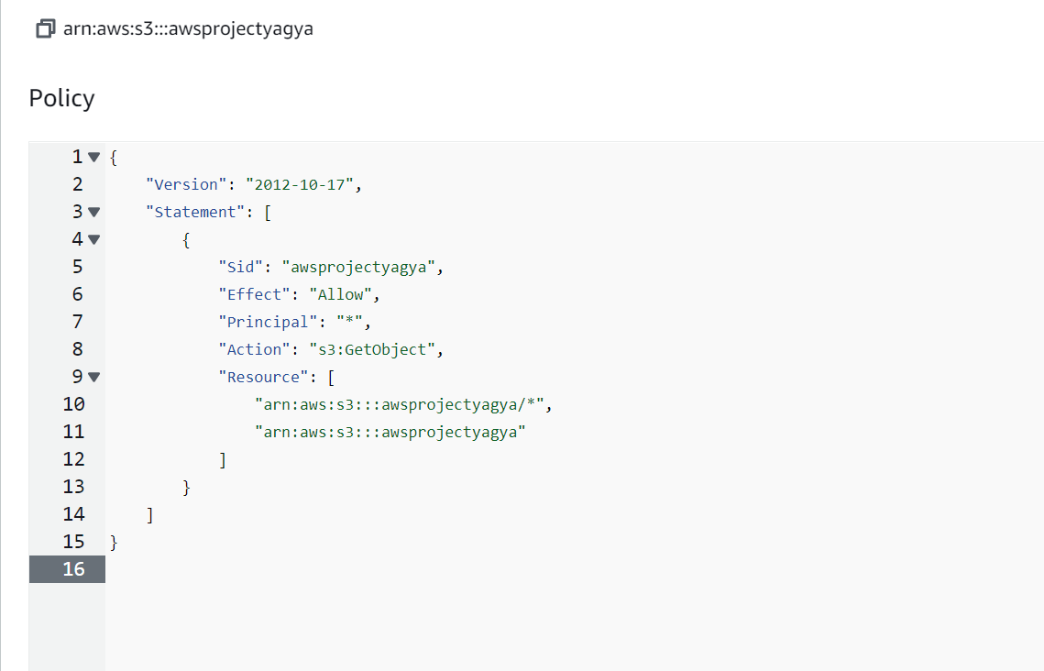

**Step 16:** The bucket policy will be successfully edited. 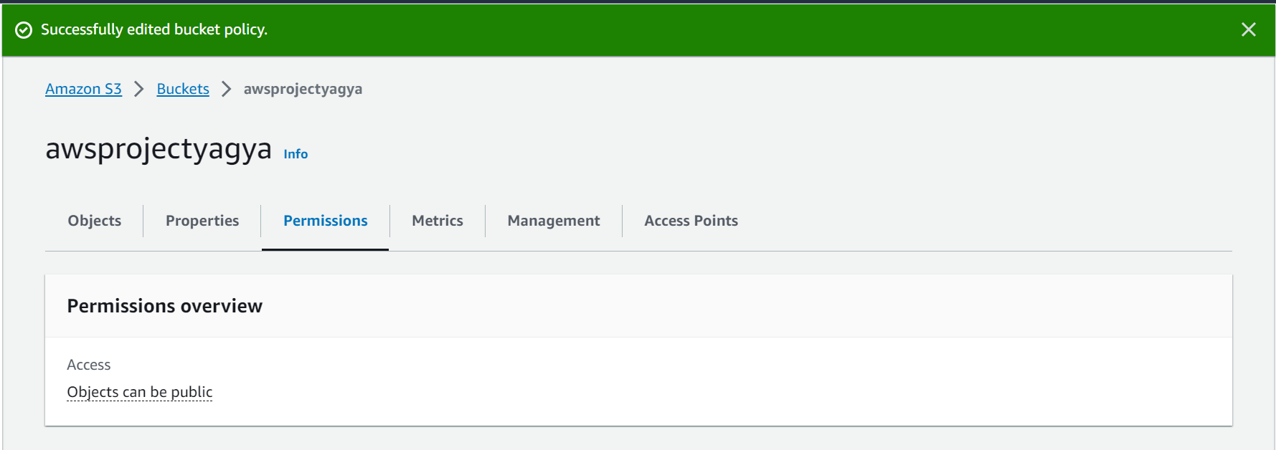

**Step 17:** To access the survey form, we can click on the object Surveyform.html.

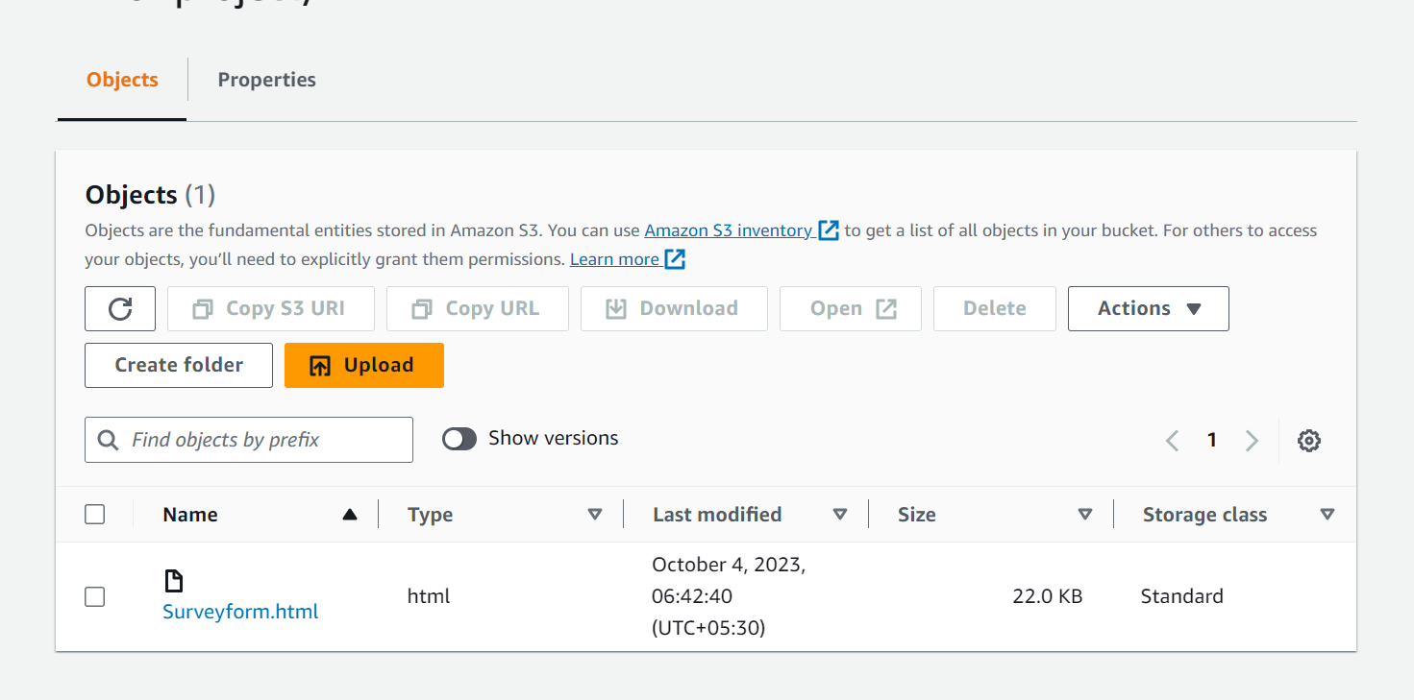

**Step 18:** Copy the object URL and paste it on the new window.

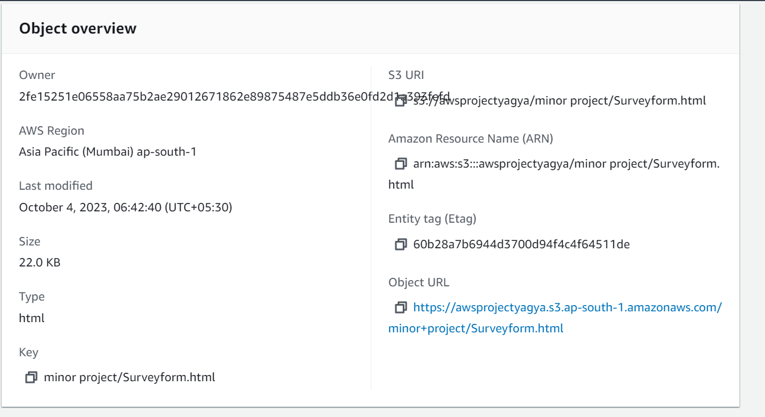

**Step 19:** We’ll be able to view the following survey form, hence hosting a static website on Amazon S3.

